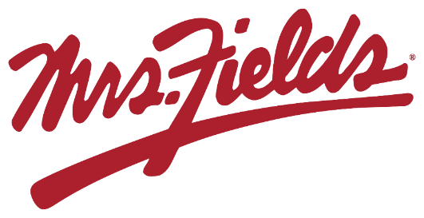

GROUP NAME
Our Fundraiser Starts TODAY!!!!!
Today we start our fundraiser with Mrs. Fields Fundraiser. Our fundraiser will support GOAL. If you sell 10 items we will reach our group goal. Start selling NOW and have all orders placed in the system by DATE.
Easy to Participate
Register & Share Online

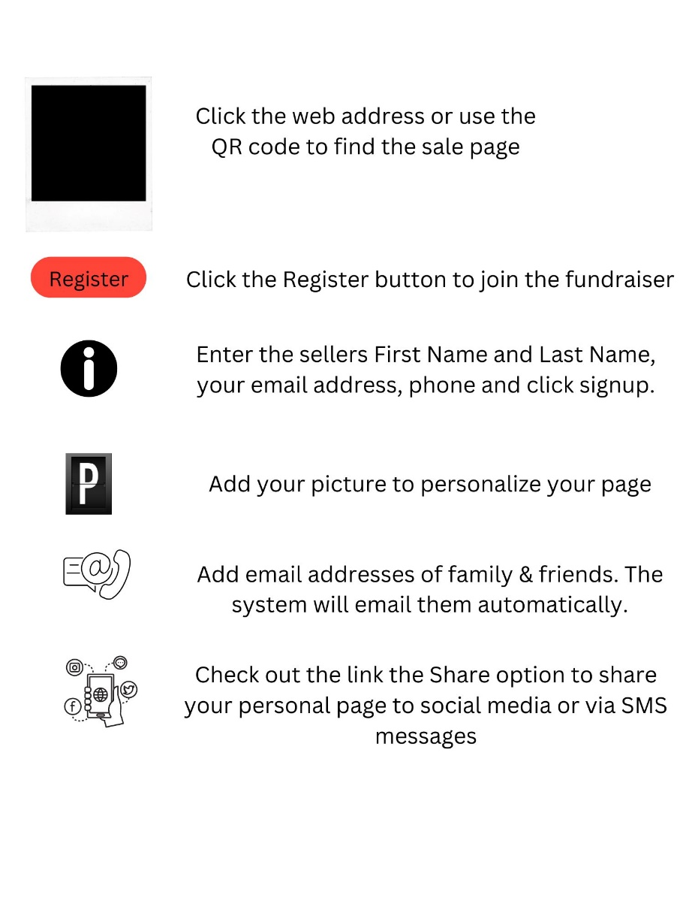
ENTER CUSTOM WEBSITE ADDRESS HERE

