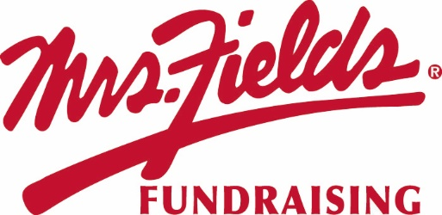
GROUP NAME
Our Fundraiser Starts TODAY!!!!!

Today we start our fundraiser with Mrs. Fields Fundraising. Our fundraiser will support GOAL.
We will work together as a team to raise
$0,000 to support our cause.

Kick Off
End Date

DATE
STARTS TODAY!!!!

Easy to Participate
1. Make checks payable to GROUP NAME.
2. Please fill out your order form completely with your Group Name, Your Name, teacher, and phone number.
3. Total up each item on your order form at the bottom and make sure you collected the correct amount of money.
4. Take a picture of your order form for your records
5. Turn in money and the white copy of your order form to your sponsor.
6. Keep the yellow copy to deliver the items to each person who purchased.

Questions regarding the fundraiser? Contact NAME at EMAIL

