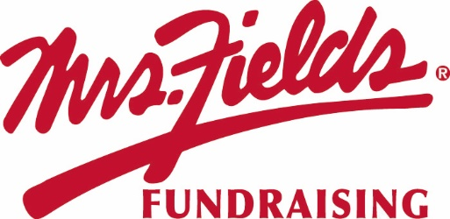
GROUP NAME
Our Fundraiser Starts TODAY!!!!!
Today we start our fundraiser with Mrs. Fields Fundraising. Our fundraiser will support GOAL.
STARTS TODAY!!!!
We will work together as a team to raise
$0,000 to support our cause.
Kick Off
End Date
DATE

2 Easy Ways to Participate
Order on Paper | Order Online
1. Make checks payable to GROUP NAME.  2. Please fill out your order form completely with your Group Name, Your Name, teacher, and phone number.  3. Total up each item on your order form at the bottom and make sure you collected the correct amount of money. DO NOT INCLUDE ONLINE ORDERS ON YOUR ORDER FORM.  4. Take a picture of your order form for your records  5. Turn in money and the white copy of your order form to your sponsor.  6. Keep the yellow copy to deliver the items to each person who purchased. | 1. Use the Campaign ID number #, custom web address below, or scan the QR Code and click on REGISTER at the top in the red bar.  2. Create your custom page, add your picture and update your message. Create a video message.  3. Add your contacts email addresses and cell phones to the site and start sharing on social media to your family and friends.  4. All items will deliver to your group and you will deliver the items to each person who purchased. NO SHIP TO HOME.  5. Go to your online platform to see who ordered what items
ENTER CUSTOM WEBSITE ADDRESS HERE
Questions regarding the fundraiser? Contact NAME at EMAIL

