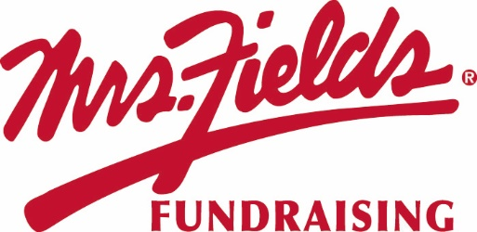
GROUP NAME
Our Fundraiser Starts TODAY!!!!!

Today we start our fundraiser with Mrs. Fields Fundraising. Our fundraiser will support GOAL.
We will work together as a team to raise
$0,000 to support our cause.

Kick Off
End Date
STARTS TODAY!!!!
DATE

Easy to Participate
Order Online Only
1. Use the Campaign ID number #, custom web address below, or scan the QR Code and click on REGISTER at the top in the red bar.
2. Create your custom page, add your picture and update your message. Create a video message.
3. Add your contacts email addresses and cell phones to the site and start sharing on social media to your family and friends.
4. All items will deliver to your group and you will deliver the items to each person who purchased. NO SHIP TO HOME.
5. Go to your online platform to see who ordered what items
ENTER CUSTOM WEBSITE ADDRESS HERE

Questions regarding the fundraiser? Contact NAME at EMAIL

