GROUP NAME
Our Fundraiser Starts TODAY!!!!!
Today we start our fundraiser with Mrs. Fields Ship to Home. Our fundraiser will support GOAL. We will work together as a team to raise $0,000 to support our cause.
DATE
STARTS TODAY!!!!
End Date
Kick Off

Easy to Participate
Share & Order Online
1. Use the custom web address or scan the QR Code below.
2. Click on REGISTER at the top in the red bar to setup your seller page.
3. Create your custom page, add your picture and update your message. You can even create a video message.
4. Add your contacts to the site and start sharing on social media to your family and friends.
5. Send out your custom weblink to your friends and family in the continental United States. They will order and pay through your online store. DO NOT COLLECT MONEY.
6. All items will deliver to the end customer’s home!

ENTER CUSTOM WEBSITE ADDRESS HERE

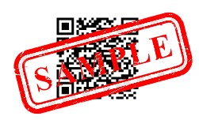

Questions regarding the fundraiser? Contact EMAIL

