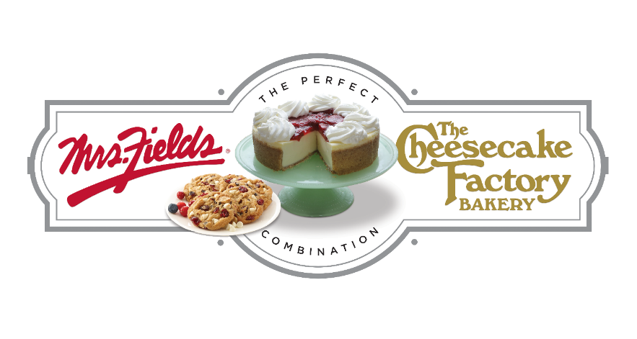

GROUP NAME
Our Fundraiser Starts TODAY!!!!!
Today we start our fundraiser with Mrs. Fields & The Cheesecake Factory Bakery Fundraising. Our fundraiser will support GOAL. We will work together as a team to raise $0,000 to support our cause.
DATE
STARTS TODAY!!!!
End Date
Kick Off

2 Easy Ways to Participate
ENTER CUSTOM WEBSITE ADDRESS HERE
Order on Paper | Order Online
1. Make checks payable to GROUP NAME.  2. Please fill out your order form on the back of the brochure and envelope completely with your name, teacher, class and phone number.  3. Total up each item on your order form at the bottom and make sure you collected the correct amount of money. DO NOT INCLUDE ONLINE ORDERS ON YOUR ORDER FORM.  4. Take a picture of your order form for your records  5. Enter the order totals on your collection envelope. Slide the money you collected and the brochure back into the envelope and return to your sponsor. | 1. Use the custom web address above or scan the QR Code and click on REGISTER at the top in the red bar.  2. Create your custom page, add your picture and update your message. You can even create a video message.  3. Add your contacts to the site and start sharing on social media to your family and friends.  4. All items will deliver to your group and you will deliver the items to each person who purchased. NO SHIP TO HOME.
Questions regarding the fundraiser? Contact NAME at EMAIL

