Social Media Posting Kit

To keep your community engaged, metrics show that updates / posts that occur at least once every 4-5 days keep information fresh and exciting for buyers and participants. Here are a few posts to help kick start your posting.
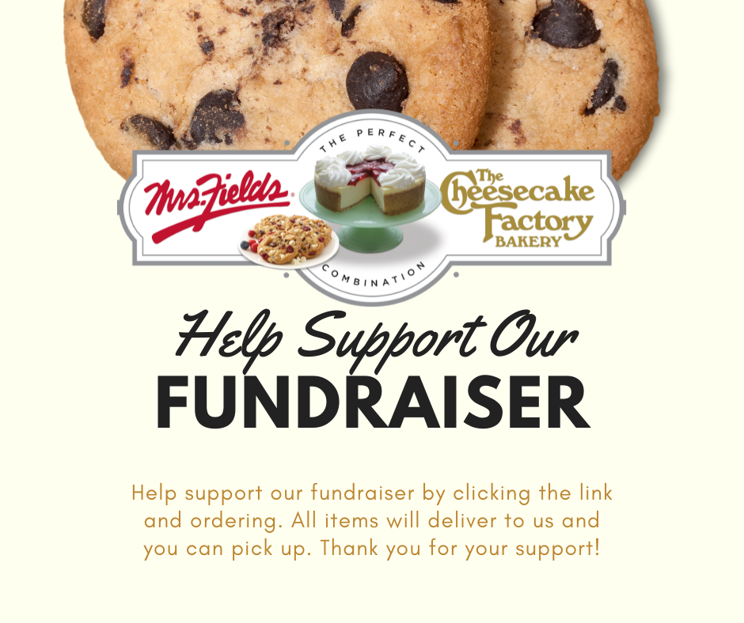
Before Your Sale – Caption this with your goal / objective for the fundraiser and what the end goal amount is.

Day 1 of Fundraiser – Caption with reminder that today starts your fundraiser so get orders in before the deadline
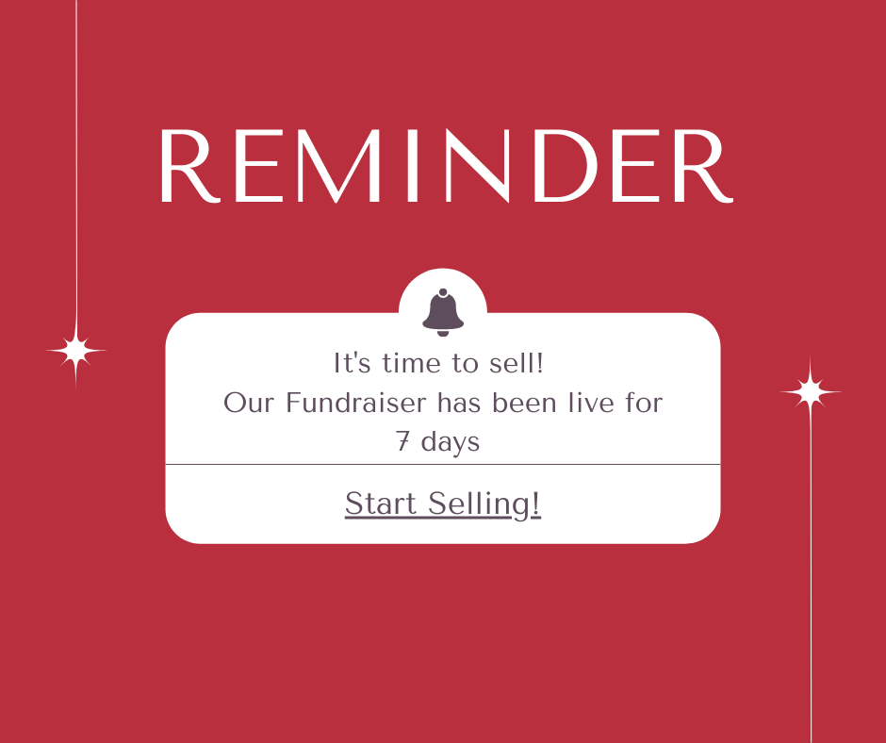
Week 1 Reminder – Caption about reminder to get your sellers engaged

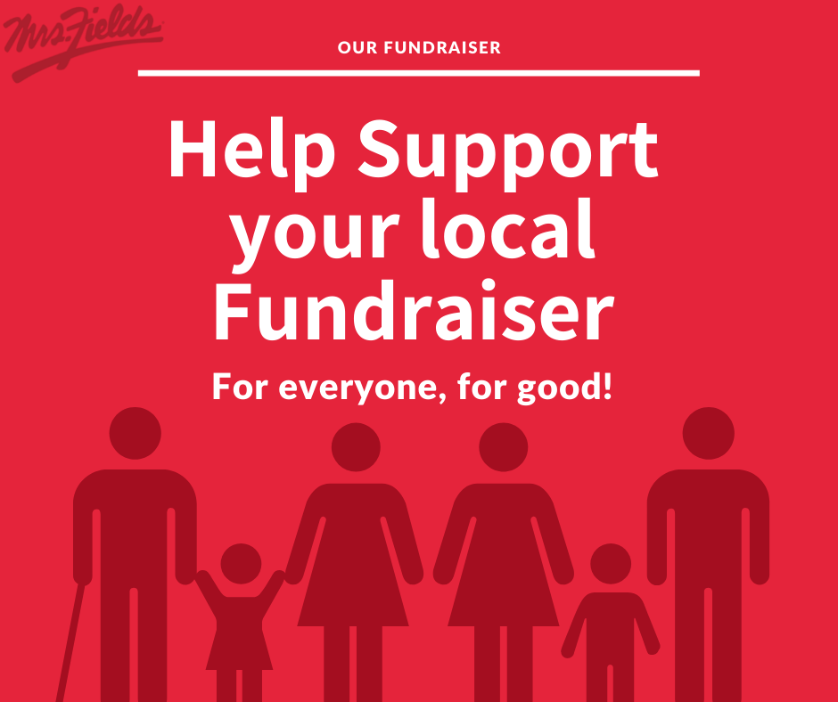
Casual Support Reminder – Caption this reminding everyone of the goal and how they can support your cause.
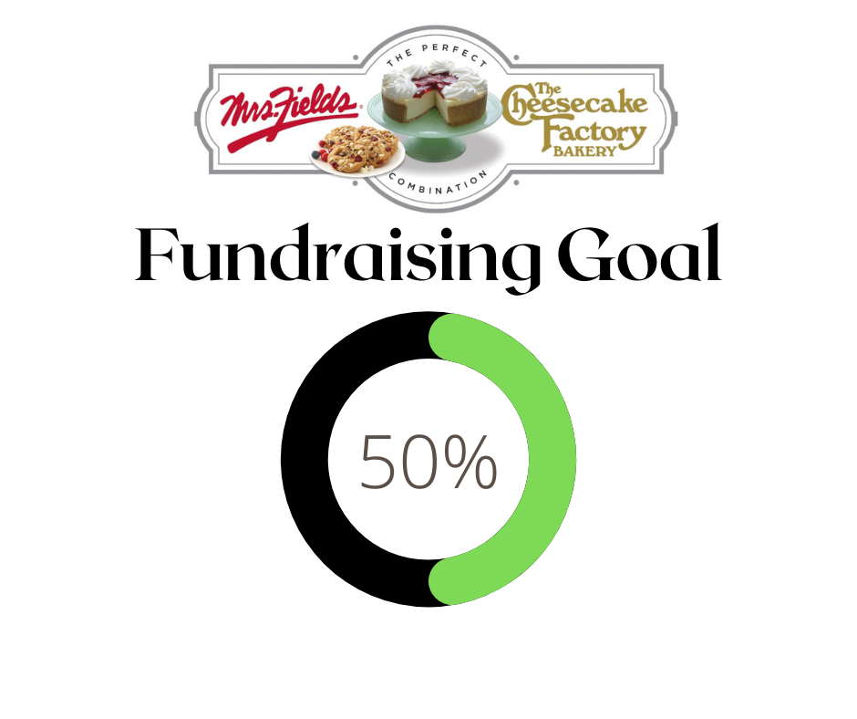
50% Goal – Caption about reaching the 50% Milestone – can check this based on online sales %

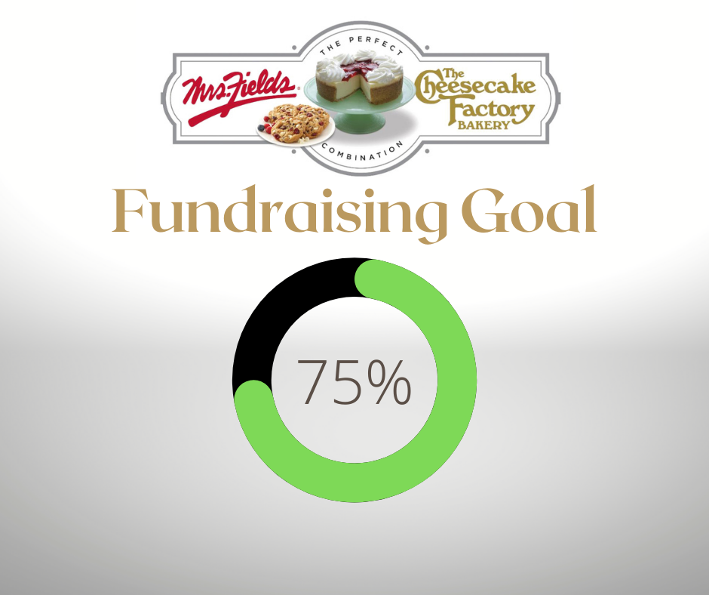
75% Goal – Casual Reminder that sellers are close to the goal!
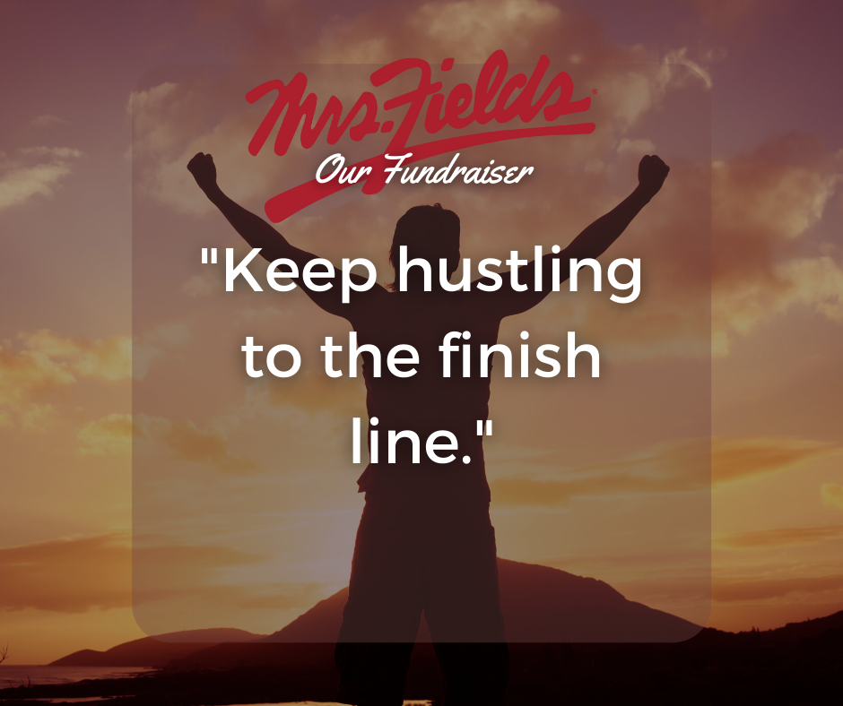
Last week Reminder – Tell the community what % of your goal your organization has achieved, remind them to finish strong and get any last orders in to help reach that goal!

Thank you Post – Thank your community for their support and let them know how well your group did! Especially if you surpassed your goal!

