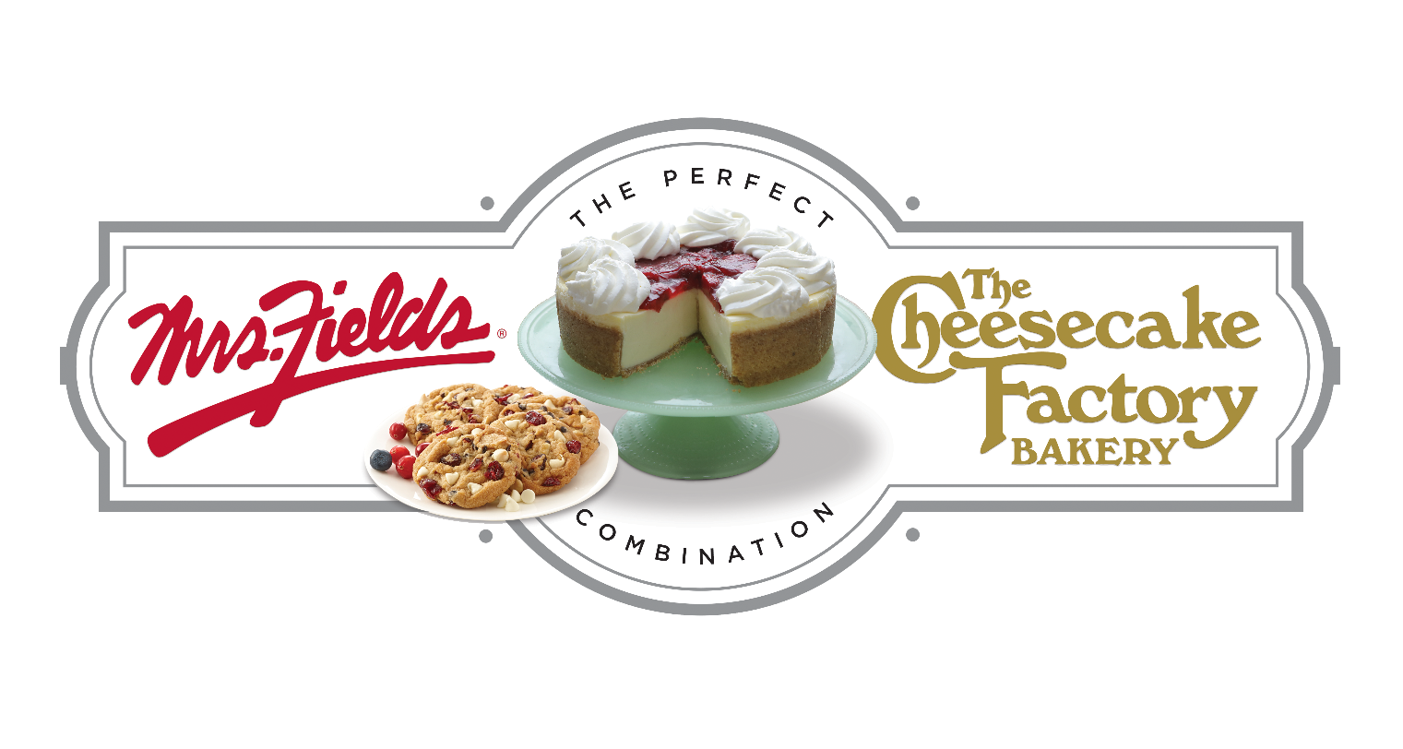

GROUP NAME
Our Fundraiser Starts TODAY!!!!!

Today we start our fundraiser with The Cheesecake Factory Bakery & Mrs. Fields Fundraising. Our fundraiser will support GOAL. We will work together as a team to raise $0,000 to support our cause.
DATE
STARTS TODAY!!!!
End Date
Kick Off

2 Easy Ways to Participate
ENTER CUSTOM WEBSITE ADDRESS HERE
Order on Paper | Order Online
1. Make checks payable to GROUP NAME.  2. Please fill out your order form and envelope completely with your name, teacher, class and phone number.  3. Total up each item on your order form and note the order totals on your collection envelope.  4. Take the white & yellow part of the order form and the cash & checks, place inside filled out collection envelope.  5. Keep the pink order form for your records and distribution to your customers. | 1. Use the custom web address or scan the QR Code and click on register at the top in the red bar.  2. Create your custom page, add your picture and update your message. You can even create a video message.  3. Add your contacts to the site and start sharing on social media to your family and friends.  4. All items will deliver to your group and you will deliver the items to each person who purchased.
Questions regarding the fundraiser? Contact NAME at EMAIL

