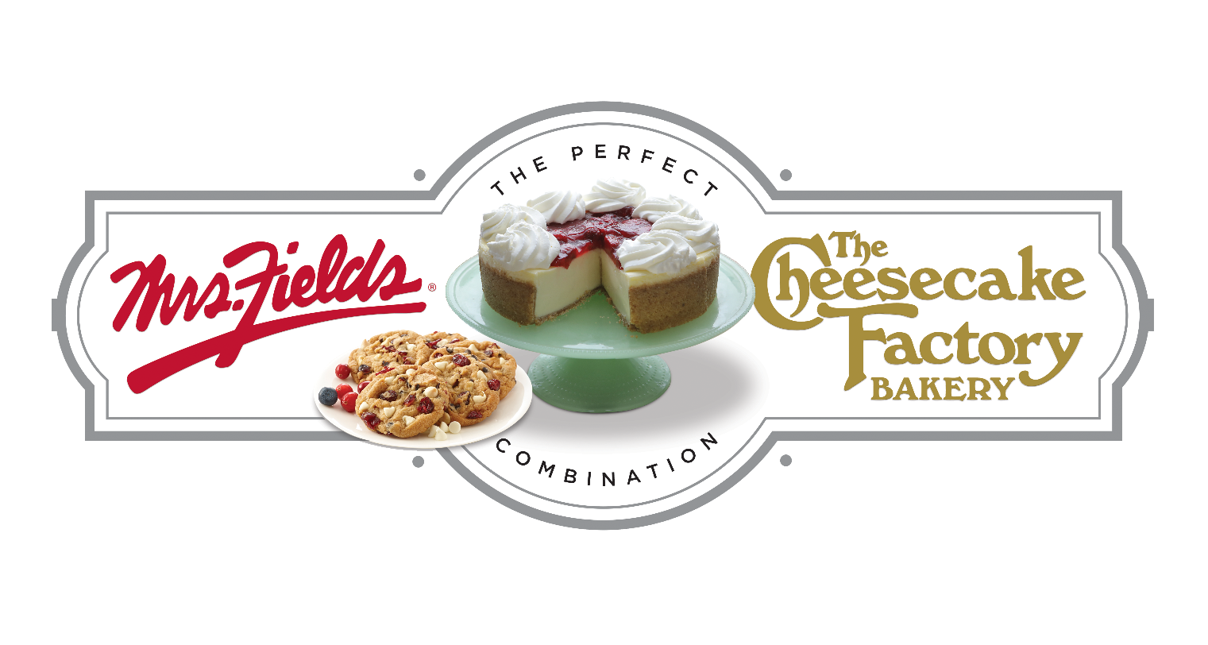

GROUP NAME
Our Fundraiser Starts TODAY!!!!!

Today we start our fundraiser with The Cheesecake Factory Bakery & Mrs. Fields Fundraising. Our fundraiser will support GOAL. We will work together as a team to raise $0,000 to support our cause.
DATE
STARTS TODAY!!!!
End Date
Kick Off

Easy to Participate
ENTER CUSTOM WEBSITE ADDRESS HERE

Order Online
1. Use the custom web address or scan the QR Code and click on register at the top in the red bar.
2. Create your custom page, add your picture and update your message. You can even create a video message.
3. Add your contacts to the site and start sharing on social media to your family and friends.
4. All items will deliver to your group and you will deliver the items to each person who purchased.
Questions regarding the fundraiser? Contact NAME at EMAIL

