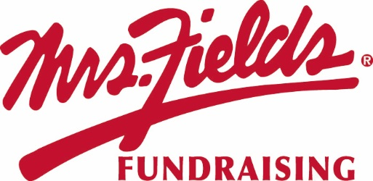

Please support our
GROUP NAME
Your Sale Starts Today!! | Pick Up Information:
Sale Ends: DATE  Order Form and Money Due | After all the orders have been placed all families will receive pickup information

HOW TO HELP?
* Show the catalog to friends, relatives and co-workers.
* Please, no unsupervised door-to-door selling.
* Please collect payment when you take the order. (No Tax)

HOW IT WORKS…
Order on Paper
1. Make checks payable to GROUP NAME.
2. Please fill out your order form and envelope completely with your name, teacher, class and phone number.
3. Total up each item on your order form and note the order totals on your collection envelope.
4. Take the white part of the order form and payment, place inside filled out collection envelope. Keep the yellow order form for your records and distribution to your customers.

We are raising money for: Type your group’s goal here…
Individual Goal: | XX Number of Items
Group Goal: | $ X,XXX

If you have questions please contact: (Organizer Contact Information).

FUNDRAISER NOTES

