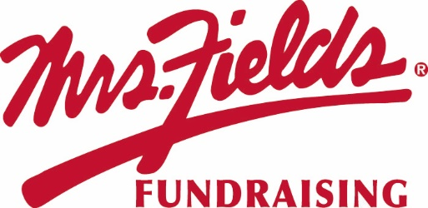
2023 SHIP TO THE HOME PROGRAM AGREEMENT
Please Complete All Information Below
Group Name:
Address for Profit Check: |  |  |  | City: |  | State: |  | Zip Code:
County: |  |  | Phone: |  |  | Email:
Fundraiser Kick Off |  |  |  | Fundraiser End Date
SPONSOR INFORMATION
Sponsor Name: |  |  |  |  | Street Address: |  |  |  |  | City:
State: |  |  |  |  | Zip Code:
Goal – Dollar Amount Raised: |  |  |  |  | # of Participating Students:

PAYMENTS & PROFITS
All orders & donation are paid for by the customer ordering by credit card. Visa, Mastercard, & Discover are the accepted. Within 21 days of the sale closing a profit check will be issued to the group to the address listed above. We will provide an email with a form that can be submitted for electronic profit check transfer.
Each individual customer will be charged for the following:
- Cost of the Cookie Dough
- Up to a 5% Credit Card Processing Fee
- Up to a $3.00 system fee
- Shipping cost (real time cost)
 | Cookie Dough
Units | Fees & Delivery | Other Items Profit per Item
151+ units | No fees added to the group invoice | 40%
71-150 units | No fees added to the group invoice | 35%
1-70 units | No fees added to the group invoice | 30%
Donations
No Minimums | $50 Donation | 70% - $35.00
No Minimums | $75 Donation | 70% - $52.50

FUNDRAISER TERMS
Materials & Incentives:
Digital materials that can be used will be emailed out once the completed contact is received and processed. The group is responsible for promoting the fundraiser. FRM recommends you allocate a portion of your profits for incentives.
Sponsor Initials: ____________
Delivery & Profit:
Orders will be shipped within 21 days after the fundraiser has ended. When items ship out each customer will receive an email with a tracking number. Profit and fees are determined by the total number of units sold. This fundraiser ships items from October to March.
Sponsor Initials: ____________
Missing/Replacements:
Each customer needs to submit with a photo and order number to https://mrsfieldsfundraising.com/shiphomemissing/ Once the claim is submitted we will work with the customer directly. If the claim is substantiated, we will refund the customer.
Sponsor Initials: ____________
SIGNATURES
Account Authorized Signature: |  | DATE:

